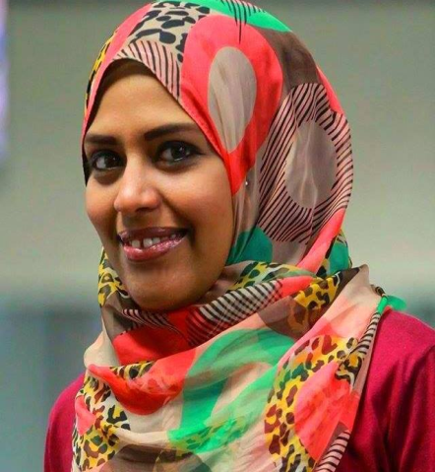

Hoda Zakaria
Journalist with over10 years of experience in journalism, media commination and public relations
Phone: (02)01007025310 | Email: Hoda.Zakaria90@gmail.com
Address: 7st. Abdelsalam Badreldin- Zahraa- Masrelqadima -Cairo- Egypt

Experience
Web Editor Youm7 Newspaper culture department - Cairo –July 2009-March 2012
Edited news, created new idea for features, researched stories, conduct interviews

Deputy Head of Investigative department  Youm7 newspaper  Cairo march 2012 till now
Working on investigative stories. Write reports. Make researches

Senior of Documentary unit  Youm7 Newspaper  July 2016 till now
Produce documentary reports and short movies.

Another Experience

Through My work , I got a lot of awards such as :

2013  2015  2016 | 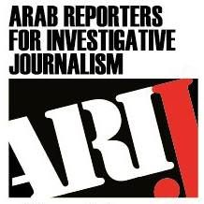  Arab Reporters for Investigative Journalism Network with International Center for Journalists  The best electronic investigation from the Women's Commission at UN  Arab journalism award 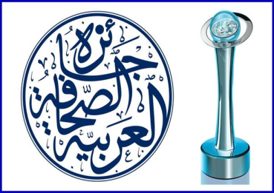

2016 Egyptian Journalists Syndicate award “woman department”

2017 Egyptian Journalists Syndicate award “investigative department “

2017 Award of the Danish-Egyptian Institute for Dialogue.

- Reported stories as freelancer for major pan-Arab news websites, television channels like BBC ,TFI and Alaraby tv network and news agencies.
.

 | Education
Mass communication Bachelors’ Degree  Cairo university  Egypt  2010 | Investigative reporter  Almasry Elyoum newspaper  Egypt  2007-2008 | Official trainer  ToT training  “Arij” network  Arab Reporters for Investigative Journalism  Jordan  2015

Key Skills

Native speaker of Arabic, high proficiency in English, Daily user of Microsoft office, social networking, and internet databases, Adept at creating and maintaining relationships with colleagues and sources.

Personal

Egyptian National
Born February1,1990
Married

